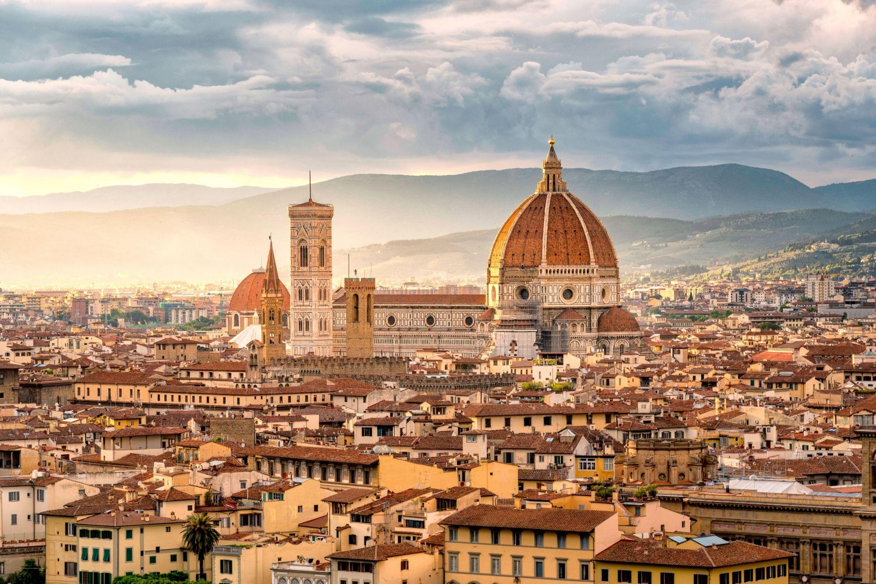

What makes Florence unique in the world is its artistic and cultural heritage. The University of Florence, illustrious for its origins and history, still keeps this tradition alive today.

Florence boasts an exceptional artistic heritage, a glorious testimony of its centuries-old civilization. Today it is an important international cultural centre, renowned for its academies, art schools and scientific institutes. The city is an active and lively cultural centre with many exhibitions and art festivals taking place every year.

**Florence will host the IACE Hall of Fame 2024!**

**IACE Hall of Fame 2024 - Technical information**

The International Adult and Continuing Education Hall of Fame Conference will be held in Florence, from 7th to 9th November 2024. The Conference will take place at the Department of Education, Languages, Interculture, Literatures and Psychology (FORLILPSI), in the complex in Via Laura 48, Florence ([see map](https://www.google.com/search?client=firefox-b-d&tbs=lf:1,lf_ui:2&tbm=lcl&q=forlilpsi&rflfq=1&num=10&ved=2ahUKEwj8k5aSzqn_AhVgX_EDHQchArMQtgN6BAgVEAg#rlfi=hd:;si:;mv:%5B%5B43.7768489,11.291721899999999%5D,%5B43.7697644,11.2614954%5D%5D)), right close to the Dom.

The Induction Ceremony will take place at the Rectorate Building in Piazza San Marco, 4 (3 minutes walking from FORLILPSI location).

Some practical information is provided below.

**Registration to the IACE Hall of Fame Conference**

Registration can be made by filling in the form available at <https://docs.google.com/forms/d/e/1FAIpQLSdZdUXyIA5KDNJ4GAW8ZWujDfFacEdl73FnFpQOwqsSHragjw/viewform?vc=0&c=0&w=1&flr=0>

Registrations are encouraged as early as possible. Places are confirmed on a first-come-first-served basis.

**Accommodation**

Accommodation in Florence is of different kinds and prices depending on the venue of the accommodation, the services provided, the period of the year. Some suggestions are available at <https://www.unifi.it/index.php?module=CMpro&func=viewpage&pageid=10832&newlang=eng> and provided below.

[**YELLOWSQUARE**](https://yellowsquare.it/florence/)

Viale F. Redi, 19, 50144 Florence

There are various alternatives: dormitories, quadruple, triple and double rooms.

[**B&B Hotel Viale Amendola**](https://www.hotel-bb.com/it/hotel/firenze-city-center?utm_source=google&utm_medium=cpc&utm_campaign=IT_goo_Brand_Hotel&gad_source=1&gclid=CjwKCAiArfauBhApEiwAeoB7qN9nqwIXvnbrtLLxj9kF0e0DesPh3bLPXmp8Ul-3iJ9ewNDZGitjxxoCipUQAvD_BwE)

Viale Giovanni Amendola, 34, 50121 Firenze, Italia +39 055 2343201

[**Ostello Bello**](https://ostellobello.com/it/hostel/firenze/)

Via Faenza, 56, 50123 Firenze FI

[**Secret garden**](https://www.secretgardenfirenze.com/en/home/)

Via della Colonna, 31, 50121 Firenze FI

[**25hours Hotel Florence**](https://www.25hours-hotels.com/it/hotels/firenze/piazza-san-paolino)

Address: Piazza San Paolino 1

[**NH Collection Palazzo Gaddi**](https://www.nh-hotels.com/it/hotel/nh-collection-firenze-palazzo-gaddi?campid=8435708&gad_source=1&gclid=CjwKCAiArfauBhApEiwAeoB7qGXsdcn1iAKrcxLB5ONT8C5r5UWbhd46p-m0jnJ9EBAMBjyRs9LsSxoC0vIQAvD_BwE&gclsrc=aw.ds)

Address: Via del Giglio 9, San Lorenzo

[**Grand Hotel Baglioni**](https://florence.baglionihotels.com/it/offerte/vantaggio-hotel?gad_source=1&gclid=CjwKCAiArfauBhApEiwAeoB7qCPv2hGauonAQWiaCDXCIEHZs8YdO09akSCIPtjSdCYF17n0IOg2PBoCCBIQAvD_BwE&gclsrc=aw.ds)

Address: Piazza Unità Italiana 6

[**Hotel plaza lucchesi**](https://www.hotelplazalucchesi.it/)

Address: Lungarno della Zecca Vecchia, 38

[**Cellai Boutique Hotel**](https://www.hotelcellai.it/it/)

Address: Via Ventisette Aprile, 52/R

[**Tornabuoni View**](https://www.tornabuoniview.com/)

Address: Via del Parione, 1

**Hotel Loggiato dei Serviti**

Piazza Santissima Annunziata n.3, 50122 – Firenze (close to the University venue)

**Hotel Arizona**  
Via Luigi Carlo Farini 2 - 50121 Firenze

**The Social Hub**  
Viale Spartaco Lavagnini, 70-72, 50129 Firenze