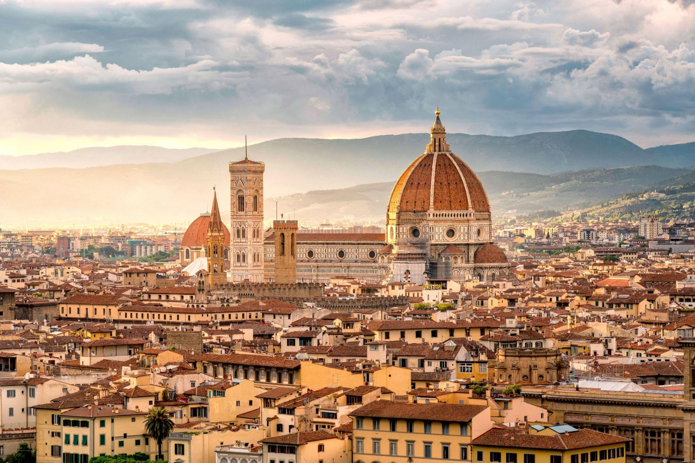

What makes Florence unique in the world is its artistic and cultural heritage. The University of Florence, illustrious for its origins and history, still keeps this tradition alive today.

Florence boasts an exceptional artistic heritage, a glorious testimony of its centuries-old civilization. Today it is an important international cultural centre, renowned for its academies, art schools and scientific institutes. The city is an active and lively cultural centre with many exhibitions and art festivals taking place every year.

**Florence will host the IACE Hall of Fame 2024!**

**IACE Hall of Fame 2024 - Technical information**

The International Adult and Continuing Education Hall of Fame Conference will be held in Florence, from 7th to 9th November 2024. The Conference will take place at the Department of Education, Languages, Interculture, Literatures and Psychology (FORLILPSI), in the complex in Via Laura 48, Florence ([see map](https://www.google.com/search?client=firefox-b-d&tbs=lf:1,lf_ui:2&tbm=lcl&q=forlilpsi&rflfq=1&num=10&ved=2ahUKEwj8k5aSzqn_AhVgX_EDHQchArMQtgN6BAgVEAg#rlfi=hd:;si:;mv:%5B%5B43.7768489,11.291721899999999%5D,%5B43.7697644,11.2614954%5D%5D)), right close to the Dom.

The Induction Ceremony will take place at the Rectorate Building in Piazza San Marco, 4 (3 minutes walking from FORLILPSI location).

Some practical information is provided below.

**Registration to the IACE Hall of Fame Conference**

Registration can be made by filling in the form available at <https://docs.google.com/forms/d/e/1FAIpQLSdZdUXyIA5KDNJ4GAW8ZWujDfFacEdl73FnFpQOwqsSHragjw/viewform?vc=0&c=0&w=1&flr=0>

Registrations are encouraged as early as possible. Places are confirmed on a first-come-first-served basis.

**Where to eat**

Here there are some places you should go to have lunch or dinner. They are all in the city centre. These are just some ideas; enjoy finding places to eat in the city centre!

[**ANTICO VINAIO**](https://www.allanticovinaio.com/)

Via dei Neri 74

If you want to eat real street food in Florence, you should try this “schiacciata” (a salty flat bread). There are many ingredients you can choose between. You can also have a glass of wine to accompany the meal. Fair prices.

[**MERCATO CENTRALE**](https://www.mercatocentrale.it/)

Piazza del Mercato Centrale

There are many food stands and restaurants in the market. It is a good choice if you want to try different types of food in the same place.

[**UN CAFFE’**](https://uncaffe.business.site/?utm_source=gmb&utm_medium=referral)

Via Cesare Battisti, 2, 50121 Firenze FI

[**IL VECCHIO E IL MARE**](https://www.ilvecchioeilmare.com/)

Via Vincenzo Gioberti 61

This restaurant is famous both for pizza and for fish meals.

[**RISTORANTE LE CARCERI**](https://www.ristorantelecarceri.it/)

Piazza della Madonna della Neve, 3

This restaurant is famous both for pizza and for typical meals.

[**FISHING LAB ALLE MURATE**](https://www.fishinglab.it/firenze/)

Via del Proconsolo, 16

If you are craving for fish, this is the place for you.

**GLUTEN FREE OPTION:**

[**QUINOA**](https://ristorantequinoa.it/)

Vicolo di Santa Maria Maggiore, 1

This is a 100% gluten free restaurant and it offers many different meals.

**VEGAN OPTION:**

[**IL VEGANO BISTROT**](https://www.ilveganofirenze.it/)

Via San Gallo, 43

This is a vegan restaurant where you can find a lot of meals, all of them are 100% plant based.

**ICE CREAM:**

[**GELATERIA EDOARDO**](https://www.edoardobio.com/)

PIAZZA DEL DUOMO, 45/R - 50122 FIRENZE

The best Gelato in Florence. All products are organic and each production chain is controlled and certified. High quality that is why is a little more expensive.

[**GELATERIA LA CARRAIA**](https://www.gelaterialacarraia.it/)

Piazza Nazario Sauro 25

One of the best and famous ice cream shops in Florence. The ice cream is creamy and softy, there are many flavours you can choose between. High quality and fair prices.